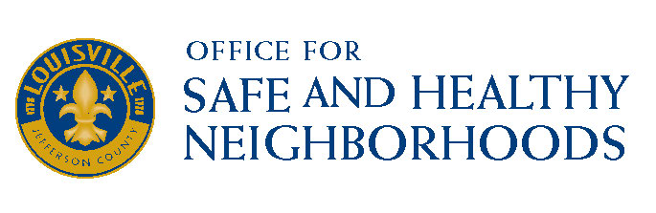
External Agency Fund –Application Process

The Office for Safe and Healthy Neighborhoods is now accepting applications from qualified non-profits that are committed to providing services that achieve meaningful outcomes for Metro citizens in the following service categories (which the agencies self-select), and are related to core areas of the One Love Louisville strategic planning process:

Target Population for services should be Youth ages 14-24 and their families
- Decreasing violence in targeted Zones of Hope neighborhoods- Russell, Shawnee, Newburg, Parkland, California
- Family and Community Wellness
- Community/Neighborhood Organizing
- Career Readiness and Successful, Meaningful Employment
- Academic Readiness and Achievement
- Show evidence of using a Public Health approach to reducing violence

In order to compete for External Agency Funds, the agency must have or have applied for 501(c)3 status from the Internal Revenue Service. In addition, each agency must be in good standing with the Jefferson County Revenue Commission and the Kentucky Secretary of State. Finally, each agency must serve residents of Louisville/Jefferson County. ALL applications must be completed and returned to the Office for Safe and Healthy Neighborhoods by January 20, 2017 at 4pm. Please drop them off at 527 West Jefferson 2nd Floor to Laura Hammer or Director Rashaad Abdur - Rahman or scan and email them to Laura.Hammer@louisvilleky.gov.

To continue to keep the application process simple, with increased operational efficiencies, and highlight program outcomes, Louisville/Jefferson County Metro Government will continue to do the following:
- Agencies will submit applications for all EAF online.
- Agencies will be required to report on S.M.A.R.T (Specific, Measureable, Attainable, Relevant, Time-Based) goals and measurable outcomes.
- Agencies will be required to provide information regarding all funding received through Metro Government and other sources.

Panel members from the Office of Safe and Healthy Neighborhoods Advisory Council will score the applications and make final recommendations. The panel members will be asked to score each application based on the following criteria:
- Does the program clearly address the “Primary Focus” neighborhood area identified?
- Does the program demonstrate applying a Public Health lens to its proposal?
- Does the program serve primarily Jefferson County residents?
- Do the goals and outcomes appear S.M.A.R.T?
- Did the agency identify how outcomes would be measured?
- Does it appear the agency has the capacity to conduct the program based on number of individuals and families to be served?
- Did the agency provide reasonable proof of success in reaching goals/outcomes in previous years? Can the agency demonstrate a “proof of concept” using models, research, or examples from other agencies or programs?
- Is it clear as to how the program will be enhanced or expanded as a result of the funding?
- Does it appear that the items in the budget align with the program description?
- Does it appear the agency provided the full cost for the program (Metro and Non-Metro dollars)?
- Are all items listed allowable expenses?
- If applicable, are descriptions provided for the line items that needed an explanation?
- Does the agency demonstrate collaboration or partnership with other community organizations?
- Does the agency appear to rely heavily on Metro to continue the program?
- Does the agency have a plan to eliminate the need for metro funding?
- Is the requesting agency making an observable effort to secure other funding?
Panel members will send in their scores, discussion, and come to a group consensus on the agencies funded and at what funding amounts. The recommendations will then be submitted as a part of the budget process for review.

The programs that will be funded will be notified no later than January 31, 2017 and will be expected to begin programming immediately. The funding for this initiative is made possible by surplus funds that will end on June 30, 2017. A final report will be due on the initiative by July 30, 2017.

Selected funding recipients will be expected to attend a mandatory training on the Public Health approach to violence prevention prior to beginning their programs.

Recipients will be highly encouraged to join One Love Louisville Community Plan work groups.

Additional questions can be directed to Maryam Ahmed at (502) 574-1903 or Maryam.Ahmed@Louisvilleky.gov

